
Faculty of Science

Course: CSCI 2020u – Software System Development & Integration
Component: Assignment
Weight: 10%
Deadline: March 5, 2020 (due by 11:59pm)

Collaboration Policy
You are permitted to work on this assignment in a team, and submit the results as a team. For this sort of assignment, with an open-ended component, the collaboration between multiple team members can be beneficial. Between groups, however, please limit the discussion to the level of general strategy (not code). Groups of size 2 are recommended. Larger groups will be considered with the proviso that the marker will mark your assignment with higher expectations. In any case, be sure that all members of the team fully understand all code, otherwise they will miss intended learning objectives, which may be a considerable disadvantage at exam time.

How to Submit
You will maintain a git repository for this assignment, which is a public repository. To submit the assignment, create a single file ‘README.txt’ that contains instructions on how to download, compile, and run your codes for each question. A .zip, .7z, or .rar file will not be acceptable. Also submit this word file (once you complete) into related drop box on Blackboard before deadline.

Note: Comments are mandatory. Failure to properly document your program will result in a deduction on the marks you receive for this (and any other) assignment.

Remember:
You need to complete this file and submit it in related drop box on Blackboard, in addition to uploading your codes in your git repository, before deadline.

Question 1: Displaying Three Cards

Problem Description:
Display a frame that contains three labels. Each label displays a card, as shown in the figure below. The card image files are named 1.png, 2.png, ..., 54.png and stored in the image/card directory. All three cards are distinct and selected randomly.

The image icons can be found in the attached card folder.

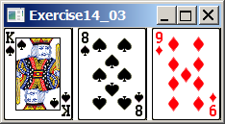

Your Task:
- Create three ImageView and set their icons using the images.
- Display three images from 54 image cards randomly.

Your Code:
Copy-paste your code here:

package code;
import javafx.application.Application;
import javafx.scene.Scene;
import javafx.stage.Stage;
import javafx.scene.layout.HBox;
import javafx.scene.image.Image;
import javafx.scene.image.ImageView;
import java.util.Random;
public class P1 extends Application {
@Override
public void start(Stage primaryStage) throws Exception {
// layout
HBox layout = new HBox();
// variables used to store images
final int numCards = 3;
Image[] cards = new Image[numCards];
ImageView[] images = new ImageView[numCards];
String file;
// random setup
Random rand = new Random();
int randomValue;
// generate random cards
for(int i=0; i<3; i++) {
randomValue = rand.nextInt(54); // generate card number (0-53)
file = "/Cards/"+(randomValue+1)+".png"; // create file path
cards[i] = new Image(file); // create image
images[i] = new ImageView(cards[i]); // create image view
layout.getChildren().add(images[i]); // add imageview to layout
}
// setup display
primaryStage.setScene(new Scene(layout));
primaryStage.setTitle("Question_1");
primaryStage.show();
}
public static void main(String[] args) { launch(args); }
}

Screen shots:
Include two screen shots here:

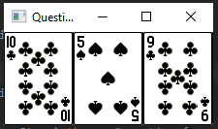
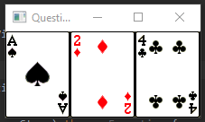

Question 2: Investment-Value calculator

Problem Description:
Write a program that calculates the future value of an investment at a given interest rate for a specified number of years. The formula for the calculation is as follows:

futureValue = investmentAmount * (1 + monthlyInterestRate)years*12

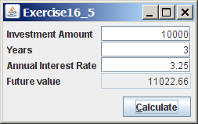

Your Task:
Use text fields for interest rate, investment amount, and years. Display the future amount in a text field when the user clicks the Calculate button, as shown in the figure.

Your Code:
Copy-paste your code here.

package code;
import javafx.application.Application;
import javafx.scene.Scene;
import javafx.stage.Stage;
import javafx.scene.layout.BorderPane;
import javafx.scene.layout.GridPane;
import javafx.scene.layout.HBox;
import javafx.scene.control.Label;
import javafx.scene.control.TextField;
import javafx.scene.control.Button;
import javafx.geometry.Pos;
import javafx.geometry.Insets;
import java.text.DecimalFormat;
public class P2 extends Application {
private Label amountLabel, yearsLabel, interestLabel, futureLabel;
private TextField amountText, yearsText, interestText, futureAmount;
private Button calculate;
private DecimalFormat df;
@Override
public void start(Stage primaryStage) throws Exception {
// initialize decimal format
df = new DecimalFormat("0.00");
// layout
BorderPane pane = new BorderPane();
pane.setTop(getGridPane());
pane.setBottom(getHBox());
// setup
primaryStage.setScene(new Scene(pane));
primaryStage.setTitle("Question_2");
primaryStage.show();
}
private GridPane getGridPane() {
// layout
GridPane layout = new GridPane();
layout.setVgap(0);
layout.setHgap(5);
layout.setPadding(new Insets(10, 10, 0, 10));
// label definitions
amountLabel = new Label("Investment Amount");
yearsLabel = new Label("Years");
interestLabel = new Label("Annual Interest Rate");
futureLabel = new Label("Future Value");
// add labels to layout
layout.add(amountLabel, 0, 0);
layout.add(yearsLabel, 0, 1);
layout.add(interestLabel, 0, 2);
layout.add(futureLabel, 0, 3);
// text field declarations
amountText = new TextField();
amountText.setAlignment(Pos.BASELINE_RIGHT);
yearsText = new TextField();
yearsText.setAlignment(Pos.BASELINE_RIGHT);
interestText = new TextField();
interestText.setAlignment(Pos.BASELINE_RIGHT);
futureAmount = new TextField();
futureAmount.setAlignment(Pos.BASELINE_RIGHT);
futureAmount.setStyle("-fx-background-color: #F2F2F2;");
// add textfields to layout
layout.add(amountText, 1, 0);
layout.add(yearsText, 1, 1);
layout.add(interestText, 1, 2);
layout.add(futureAmount, 1, 3);
return layout;
}
private HBox getHBox() {
// layout
HBox layout = new HBox();
layout.setPadding(new Insets(5, 10, 10, 0));
// button declaration
calculate = new Button("Calculate");
// set button action
calculate.setOnAction(e -> {
futureAmount.setText("");
double future = 0;
double amount = isDouble(amountText);
double years = isDouble(yearsText);
double interest = isDouble(interestText);
future = futureAmount(amount, years, interest);
if(amount >= 0 && years >= 0 && interest >= 0)
futureAmount.setText(""+df.format(future));
});
// add button to layout
layout.getChildren().add(calculate);
layout.setAlignment(Pos.BOTTOM_RIGHT);
return layout;
}
// calculate future investment
private double futureAmount(double amount, double years, double interest) {
return (amount * (Math.pow((1 + interest/1200),(years*12))));
}
// verify textfield is of double type
private double isDouble(TextField field) {
try {
double value = Double.parseDouble(field.getText());
return value;
} catch(NumberFormatException e) {
field.setText("Invalid Input");
return -1;
}
}
public static void main(String[] args) { launch(args); }
}

Screen shots:
Include two screen shots here:

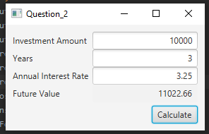
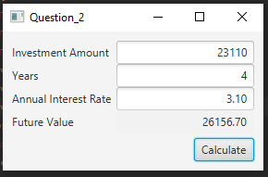
Question 3: Dragging Points on a Circle

Problem Description:
Draw a circle with three random points on the circle. Connect the points to form a triangle. Display the angles in the triangle. Use the mouse to drag a point along the perimeter of the circle. As you drag it, the triangle and angles are redisplayed dynamically.

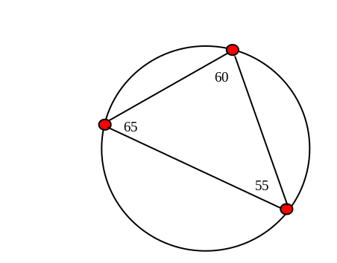

Here is the formula to compute angles:

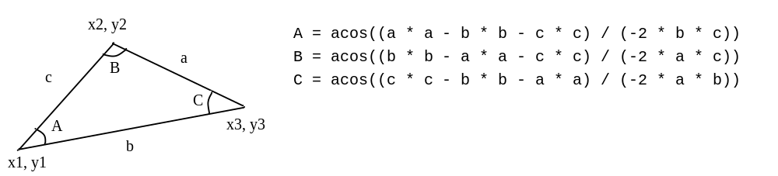

Your Code:
Copy-paste your code here:

package code;
import javafx.application.Application;
import javafx.scene.Scene;
import javafx.stage.Stage;
import javafx.scene.layout.Pane;
import javafx.scene.shape.Circle;
import javafx.scene.paint.Color;
import javafx.scene.shape.Line;
import javafx.scene.text.Text;
import javafx.scene.text.Font;
import javafx.event.EventHandler;
import javafx.scene.input.MouseEvent;
import java.util.Random;
public class P3 extends Application {
private Random rand;
private int radius = 75;
private int center = 150;
private final int numDots = 3;
private double[][] points;
private Line lines[];
private double sideLengths[];
private int[] angleValues;
private Text angles[];
@Override
public void start(Stage primaryStage) throws Exception {
// layout
Pane pane = new Pane();
rand = new Random();
// shape
Circle outer = new Circle(radius);
outer.setCenterX(center);
outer.setCenterY(center);
outer.setStroke(Color.BLACK);
outer.setFill(Color.WHITE);
// generate points
points = new double[2][numDots];
for(int i=0; i < points[0].length; i++) {
points[0][i] = initX();
points[1][i] = initY(points[0][i]);
}
// lines for initial setting
sideLengths = new double[numDots];
lines = new Line[numDots];
for(int i=0; i < numDots; i++) lines[i] = new Line();
updateLines();
// display initial angles
angleValues = new int[numDots];
angles = new Text[numDots];
for(int i=0; i < numDots; i++) {
angles[i] = new Text();
angles[i].setFont(new Font(10));
}
updateAngles();
// handle mouse events
EventHandler cursor[] = new EventHandler[numDots];
// generate dots and lines
int dotRadius = 5;
Circle[] dots = new Circle[numDots];
for(int k=0; k < numDots; k++) {
dots[k] = new Circle(dotRadius);
dots[k].setCenterX(points[0][k]);
dots[k].setCenterY(points[1][k]);
dots[k].setStroke(Color.BLACK);
dots[k].setFill(Color.RED);
final int m = k;
// handle method for each dot
cursor[m] = new EventHandler<MouseEvent>() {
@Override
public void handle(MouseEvent event) {
double dotX, dotY; // x and y coordinates
double cursorX = event.getX();
double cursorY = event.getY();
// check if the cursor is within the bounds of the circle
if(cursorX >= (center - radius) && cursorX <= (center + radius)) {
dotX = cursorX;
if(cursorY < center)
dotY = generateY(dotX, true);
else
dotY = generateY(dotX, false);
points[0][m] = dotX;
points[1][m] = dotY;
dots[m].setCenterX(dotX);
dots[m].setCenterY(dotY);
// update values
updateLines();
updateAngles();
}
}
};
dots[m].addEventHandler(MouseEvent.MOUSE_DRAGGED, cursor[m]);
}
// add nodes to pane
pane.getChildren().add(outer);
for(int i=0; i < numDots; i++) {
pane.getChildren().add(lines[i]);
pane.getChildren().add(dots[i]);
pane.getChildren().add(angles[i]);
}
// setup
primaryStage.setScene(new Scene(pane,300,300));
primaryStage.setTitle("Question_3");
primaryStage.show();
}
// generates initial x value within bounds
private int initX() {
return rand.nextInt(radius * 2) + (center - radius);
}
// uses x value to create y-value in circle
private double initY(double x) {
double y = Math.sqrt(Math.pow(radius,2) - Math.pow(x-center, 2)) + 150;
if(rand.nextInt() % 2 == 0) return y;
double offset = y - 150;
return 150 - offset;
}
// gets new y based on x and +/- cursor placement
private double generateY(double x, boolean above) {
double y = Math.sqrt(Math.pow(radius,2) - Math.pow(x-center, 2)) + 150;
if(!above) return y;
double offset = y - 150;
return 150 - offset;
}
// updates lines
private void updateLines() {
// line a
lines[0].setStartX(points[0][0]);
lines[0].setStartY(points[1][0]);
lines[0].setEndX(points[0][1]);
lines[0].setEndY(points[1][1]);
// line b
lines[1].setStartX(points[0][0]);
lines[1].setStartY(points[1][0]);
lines[1].setEndX(points[0][2]);
lines[1].setEndY(points[1][2]);
// line c
lines[2].setStartX(points[0][1]);
lines[2].setStartY(points[1][1]);
lines[2].setEndX(points[0][2]);
lines[2].setEndY(points[1][2]);
updateLineLengths();
}
// updates line lengths
private void updateLineLengths() {
for(int i=0; i<sideLengths.length; i++)
sideLengths[i] = lineLength(lines[i]);
}
// calculates length of line
private double lineLength(Line line) {
return Math.sqrt(Math.pow(line.getEndX() - line.getStartX(),2) +
Math.pow(line.getEndY() - line.getStartY(),2));
}
// updates angle text placement
private void updateAngles() {
for(int i=0; i < numDots; i++) {
updateAngleValues();
angles[i].setText(angleValues[i]+"");
if(points[0][i] < center)
angles[i].setX(points[0][i] + 10);
else if(points[0][i] == center)
angles[i].setX(points[0][i]);
else
angles[i].setX(points[0][i] - 10);
if(points[1][i] < center)
angles[i].setY(points[1][i] + 10);
else if(points[1][i] == center)
angles[i].setY(points[1][i]);
else
angles[i].setY(points[1][i] - 10);
}
}
// refresh angle values
private void updateAngleValues() {
double a = sideLengths[0];
double b = sideLengths[1];
double c = sideLengths[2];
double temp;
temp = Math.toDegrees(Math.acos(((a*a) - (b*b) - (c*c)) / (-2 * b * c)));
angleValues[2] = (int) (Math.round(temp));
temp = Math.toDegrees(Math.acos(((b*b) - (a*a) - (c*c)) / (-2 * a * c)));
angleValues[1] = (int) (Math.round(temp));
angleValues[0] = 180 - angleValues[2] - angleValues[1];
}
}

Screen shots:
Include two screen shots here:

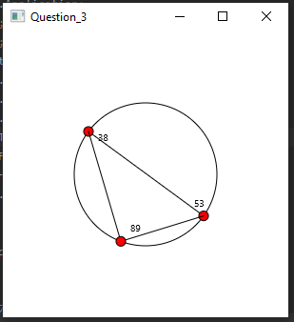

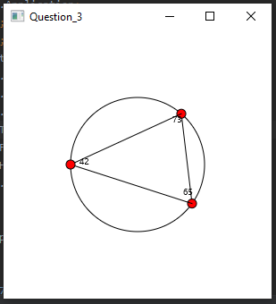
Question 4: Histogram

Problem Description:
Develop a program that displays a histogram to show the occurrences of each letter in a text area. The histogram should show the occurrences of each letter in a text file, as shown in the following figure. Assume that the letters are not case sensitive.

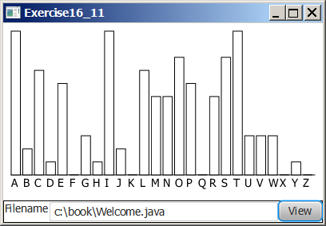

Your Task:
- Place a pane that will display the histogram in the center of the frame.
- Place a label and a text field in a panel, and put the panel in the south side of the frame. The text file will be entered from this text field.
- Pressing the Enter key on the text field causes the program to count the occurrences of each letter and display the count in a histogram.

Your Code:
Copy-paste your code here:
package code;
import javafx.application.Application;
import javafx.event.EventHandler;
import javafx.geometry.Pos;
import javafx.scene.Scene;
import javafx.scene.input.KeyCode;
import javafx.scene.input.KeyEvent;
import javafx.scene.paint.Color;
import javafx.stage.Stage;
import javafx.scene.layout.BorderPane;
import javafx.scene.layout.HBox;
import javafx.scene.layout.VBox;
import javafx.scene.shape.Rectangle;
import javafx.scene.control.Label;
import javafx.scene.control.TextField;
import javafx.scene.control.Button;
import java.io.File;
import java.io.FileNotFoundException;
import java.util.Scanner;
public class P4 extends Application {
// variables
final int alphabetLength = 26;
final int A = 'A';
final int a = 'a';
final int Z = 'Z';
final int z = 'z';
int frequency[];
Rectangle[] bars;
TextField input;
Label filename;
BorderPane pane;
Button view = new Button("View");
@Override
public void start(Stage primaryStage) throws Exception {
// store data
frequency = new int[alphabetLength];
// layout
pane = new BorderPane();
pane.setTop(graph());
// button action
view.setOnAction(event -> display());
primaryStage.setScene(new Scene(pane,400,250));
primaryStage.setTitle("Question_4");
primaryStage.show();
}
// get frequency of characters in file
public void inputData(String data) {
for(char c : data.toCharArray()){
if(c >= A && c <= Z)
frequency[c-A]++;
if(c >= a && c <= z)
frequency[c-a]++;
}
}
// reset frequencies of each letter
public void clearData() {
for(int i = 0; i < alphabetLength; i++) frequency[i] = 0;
}
// rectangles
public HBox data() {
HBox layout = new HBox();
layout.setSpacing(3);
bars = new Rectangle[alphabetLength];
int x = 0;
int y = 150;
int width = 10;
int index = 0;
int scaleFactor = 10;
for(Rectangle r : bars) {
r = new Rectangle();
r.setX(x);
r.setY(y - frequency[index]);
r.setWidth(width);
r.setHeight(frequency[index++] * scaleFactor);
r.setFill(Color.WHITE);
r.setStroke(Color.BLACK);
layout.setAlignment(Pos.BOTTOM_CENTER);
layout.getChildren().add(r);
}
return layout;
}
// return input layout
public HBox input() {
HBox layout = new HBox();
filename = new Label("Filename");
input = new TextField();
input.setMinWidth(270);
input.setOnKeyPressed(new EventHandler<KeyEvent>() {
@Override
public void handle(KeyEvent event) {
if(event.getCode() == KeyCode.ENTER)
display();
}
});
layout.getChildren().add(filename);
layout.getChildren().add(input);
layout.getChildren().add(view);
layout.setAlignment(Pos.TOP_CENTER);
layout.setStyle("-fx-border-insets: 19;" + "-fx-border-width: 1;" + "-fx-border-color: black;");
return layout;
}
// return graph layout
public VBox graph() {
VBox layout = new VBox();
layout.getChildren().add(data());
Label x_axis = new Label();
String text = " ";
for(int i=A; i <= Z; i++) {
text += (char) i + " ";
}
x_axis.setText(text);
x_axis.setAlignment(Pos.CENTER);
layout.setAlignment(Pos.BOTTOM_CENTER);
layout.getChildren().add(x_axis);
layout.getChildren().add(input());
return layout;
}
// display graph
public void display() {
clearData();
String filename = input.getText();
File file = new File(filename);
String line;
try {
Scanner scanner = new Scanner(file);
while(scanner.hasNextLine()) {
line = scanner.nextLine();
inputData(line);
}
scanner.close();
} catch (FileNotFoundException e) {
input.setText("File Not Found!");
}
pane.setTop(graph());
}
public static void main(String[] args) { launch(args); }
}

Screen shots:
Include two screen shots here:
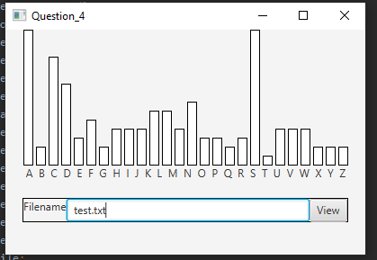

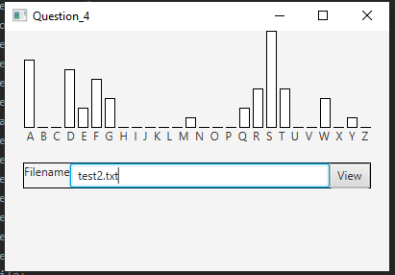
Remember:

You need to complete this file and submit it in related drop box on Blackboard, in addition to uploading your codes in your git repository, before deadline.

